ⴰⵎⴰⵣⵉⵖ
Sahara blues (Niger/Germany)
ANEWAL
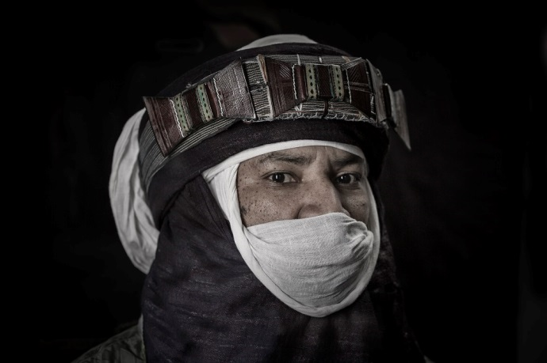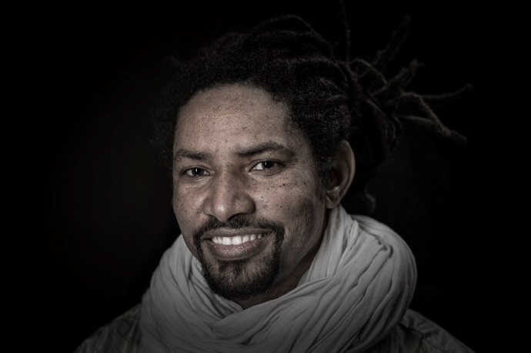
Photo: Jean Molitor
ANEWAL is the new trio of Alhousseini Anivolla´s, lead guitarist and singer of the famous desert blues band Etran Finatawa / Niger. The far travelled musician formed the new band in 2014. This group is bringing together traditional african tunes and new soundscapes.
ANEWAL has got everything that fans of this stuff have been devouring ever since desert blues went global: hypnotic two-chord jams, trance-inducing beats, biting blues-infused guitar and Anivolla’s warmly laid-back vocals sung in his local vernacular. Anivolla is an incisive and remarkably subtle guitarist, varying his attack on the strings, adding minute levels of natural distortion, his incisive, blues-infused phrases ringing out over long, swaying vamps.
Anewal´s concert is a splendid show that leads the audience right into the desert and an actual african scene. You feel cultural heritage as much as social transition with its chances, lost and tragedy. It is a powerful show transported by the world scene experienced trio especially its lead singer Alhousseini Anivolla. With ANEWAL Anivolla continues his mission as an ambassador for cultural diversity in a changing world!
90min of pure desert blues. Songs from Anivolla´s 15 year musical career and especially from his internationally acclaimed recent album “Osas-it´s time” (2017)
Three musicians on stage (voice-guitar, bass guitar, percussion)

